Feature Flag System Technical Design Document
Haijiang Ding

2026-4-25

System Architect Diagram

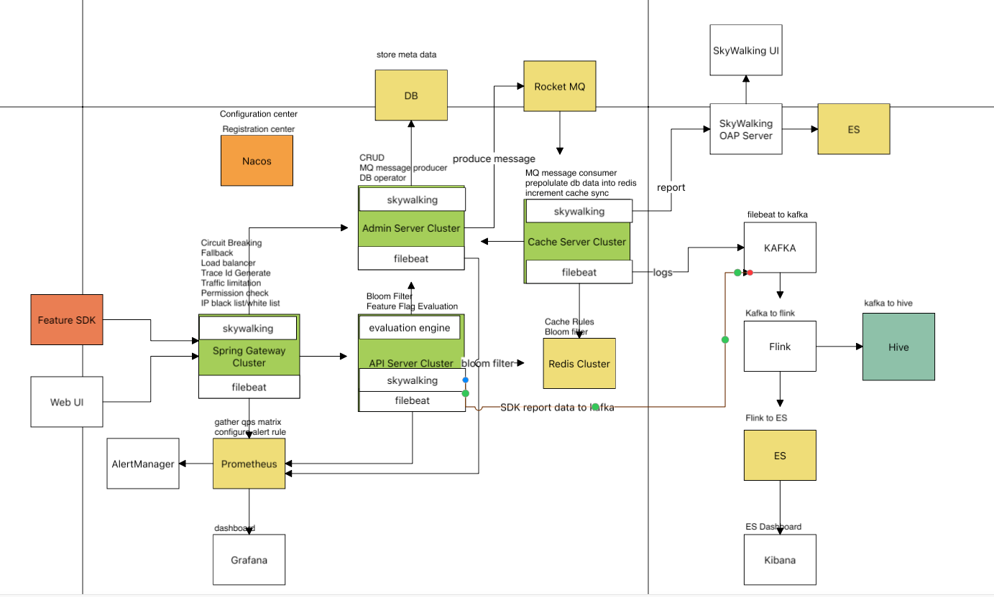

Components and responsibility
- Admin Server Cluster
  - Handle web requests
  - Operate db tables
  - Handle data query requests
  - Send data modified message to mq
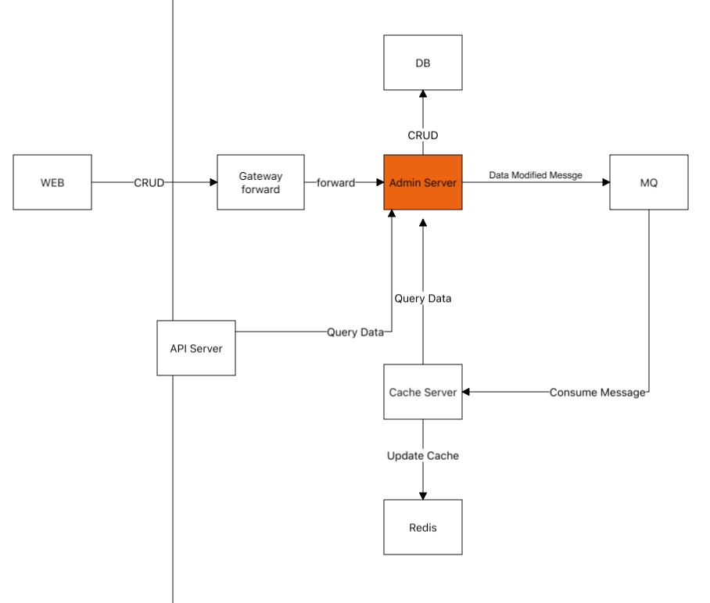
- Cache Server Cluster
  - Full data prepopulating
    - feature system configured data
    - bloom filter data prepopulate
  - Scheduled increment data loading
    - feature system modified data
    - bloom filter modified data
  - Consume mq messages to sync cache
  - Sharding key switching strategy
  - Distributed lock mechanism
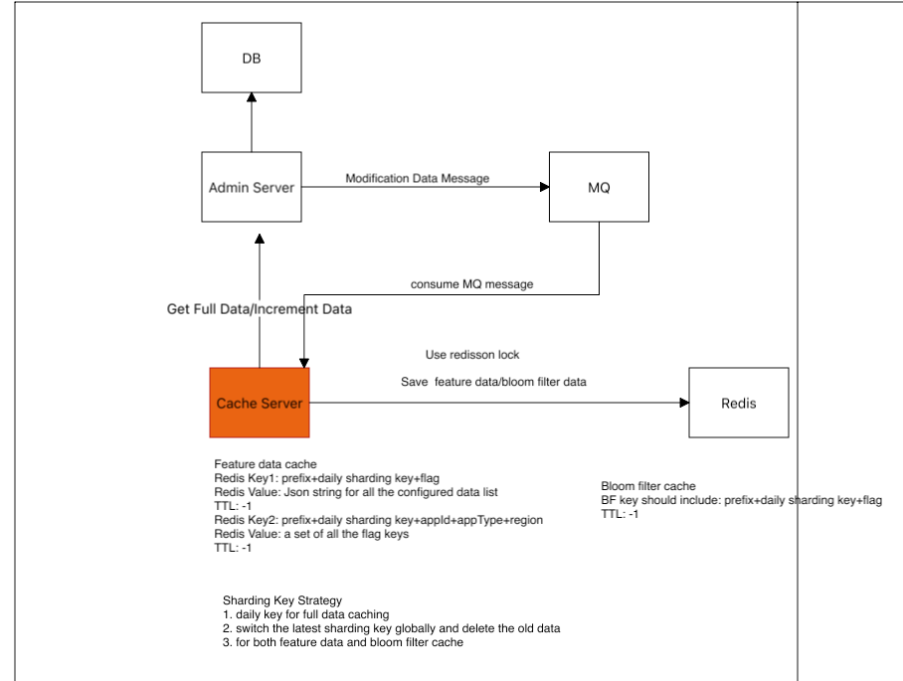
- API Server Cluster
  - Bloom filter checking for the flag key to avoid of flooding attack
  - Get related cache from redis and do the evaluation
  - Get db data by invoking the admin server in case of cache not exists
  - populate db data into redis cache
  - do the sub rule evaluations and generate the evaluation report if required
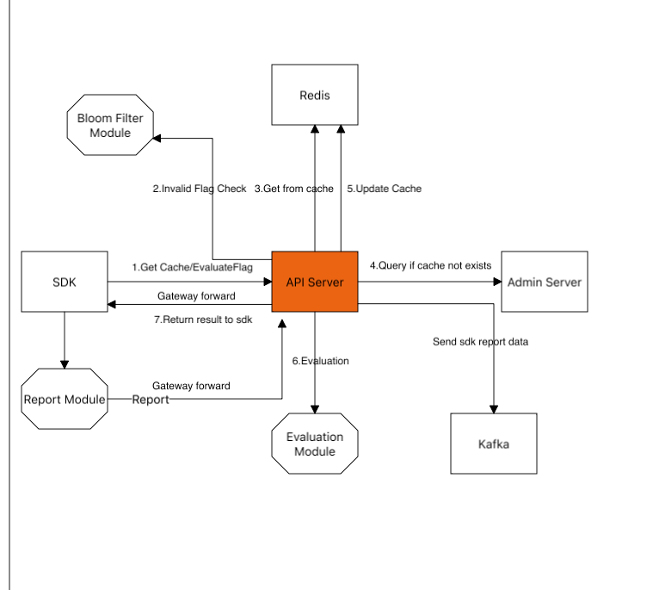
- Feature SDK
  - Initialize the local cache for appId/appType/region
  - Background job to sync the increment cache intermittently
  - to get real time flag evaluation result
  - to evaluate rules inside sdk
  - to report the evaluation result
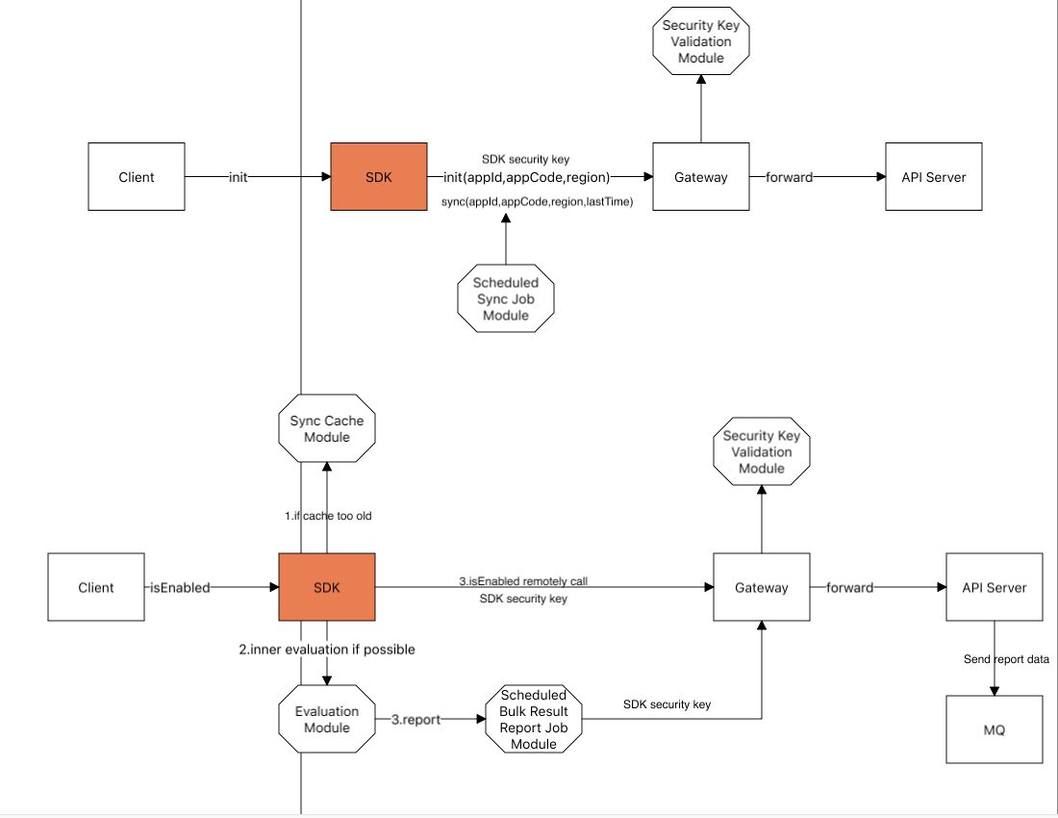
- Logging and Trace
  - skywalking suite generate unique trace id,track the invocation chain and collecting metrics include qps,latency etc.
  - filebeat, kafka,flink, es suite collect the system logs
  - prometheus collecting server metrics
  - grafana dashboard displays the prometheus metrics including jvm,cpu,memory, qps etc.
  - alert manager monitors metrics and triggers alerts
  - flink and hive undertake offline data analysis and computation
- Other components
  - Spring gateway
    - handles the routes forwarding, load balancing, rate limiting,circuit breaking, permission checking, and ip black/white list
  - Nacos
    - the registration and configuration center
  - filebeat
    - to collect log
  - prometheus/alert manager
    - to collect metrics
    - to trigger the alerts
  - grafana dashboard
    - to display the metrics
  - skywalking agent and OAP server and UI
  - rocket mq
    - to async process the modified feature configure data
  - database
    - to store the feature data
  - kafka
    - to transfer the filebeat logs data
  - flink
    - connect with kafka to transfer data into es or hive
  - elastic search and kibana
    - to store the log data and display them
  - hive
    - to store the offline data
  - redis
    - master slave mode with sentinel
    - to store the configured data
    - to store the bloom filter data

